|  |  |  |  |  |
| --- | --- | --- | --- | --- |
| DHRUV BHATT |  | |  | | --- | | **DOT-NET–21607011**  **Lab Manual**  Semester 6th  Academic Year 2019-20 Even  16/12/2019 – 16/4/2020 | |  | |



Gujarat Technological University

VVP Engineering College, Rajkot

Table of Contents

1. Create hello world console application 1
2. Aim of Practical 2 4
3. Aim of Practical 3 5
4. Aim of Practical 4 6

**Practical 1**

# Create hello world console

# step-1:Open visual studio

# G:\18ce193\captures\1.PNG

Step-2 : Select the console application and give the name as the practical 1 where the solution should be Dot-net practical

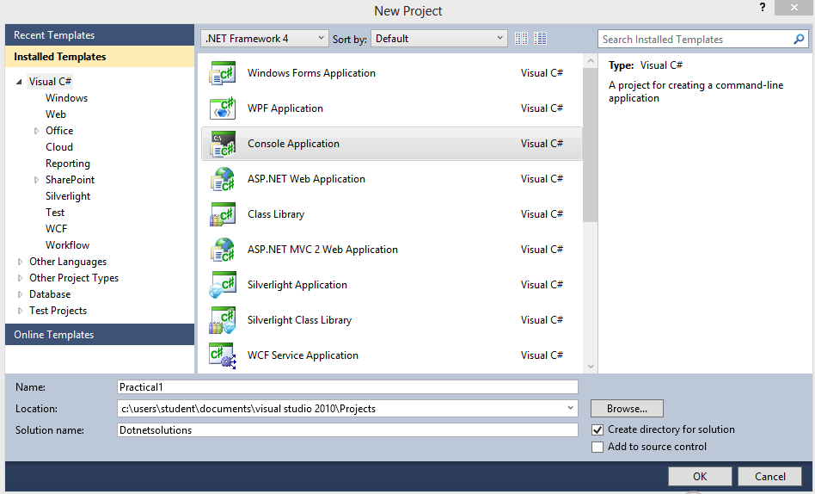

Step-3 : The file must contain the code given below

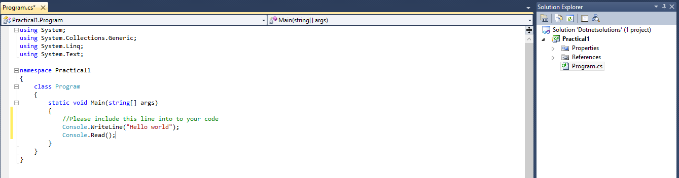

Step-4 : The output of the program is as follow

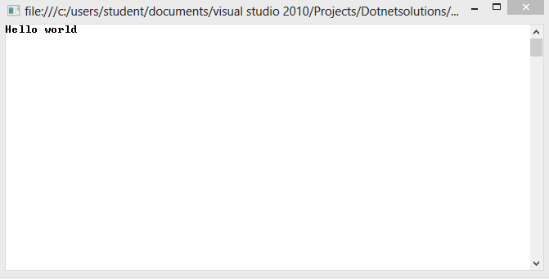

**Practical 2**

# Aim of Practical 2

**Practical 3**

# Aim of Practical 3

**Practical 4**

# Aim of Practical 4